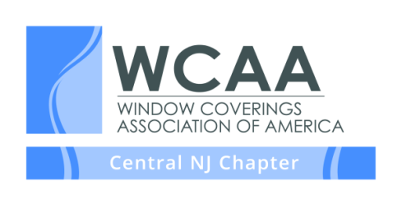
MEETING & EVENT SCHEDULE 2021

The WCAA is the nation’s leading organization representing window covering professionals, designers, decorators, retailers, installers and workrooms.

We invite you to join us at one of our NJ Chapter meetings. Unless otherwise noted, meetings are held on the first Thursday of each month from 10:00 AM – Noon via Webinar. Additional information on each meeting is posted on the website under the “More” tab one month prior to the meeting. If you would like to be placed on our mailing list or would like more information about our chapter please visit us on our website at www.wcaanj.org

January 7 (9:30 am)– Nancy Ganzekaufer, Get Ready For The New Year by Creating Your Road Map to Success

February 4 – Vita Vygovska, Scaling Your Business

March 4 – LuAnn Nigara, TBA

April 1 – Heather McManus, Don’t Leave Money on the Table

May 6 – Elki Horn, Bedding and Pillow Details

June 3 – Heather McManus, Round Table Discussion

August 5 – Allison Hagerman, Understand Hard Treatments (In person back yard meeting)

September – WCAA Holiday Party

October 1 - Madeline MacRae, Old School vs New School Marketing

November 5 – Deb Barrett, Textile Tech Support

December 5 – Diane Roberson & Robin Matthews, Window Treatments for Newbie Designers

