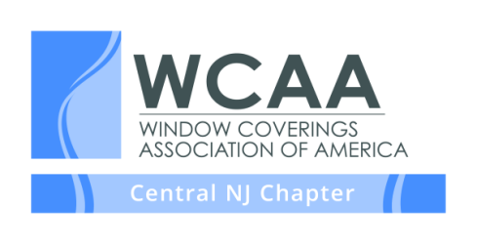
2018 MEETING & EVENT SCHEDULE

The WCAA is the nation’s leading organization representing window covering professionals, designers, decorators, retailers, installers and workrooms.

We invite you to join us at one of our Central NJ Chapter meetings. Unless otherwise noted, meetings are held on the first Thursday of each month from 10:00 AM – Noon at Somfy Systems, Dayton, NJ. If you would like to be placed on our mailing list or would like more information about our chapter please visit us on our website at www.wcaanj.org

January 4, 2018 – Nicole Heymer - Branding Grows a Business: Why and How to Define Your Brand – Join us for an interactive discussion about how people of think and describe your services – and how these things affect your bottom line. What is branding (explained in plain, useful terms)? How does it help a business? Nicole will provide tools to put these concepts into action: a branding checklist, three specific next steps to take after you leave the meeting and more.
February 1, 2018 – Healthy & Green Design – Back by popular demand, Blanche Garcia, WELL AP and LEED AP Certified, will show us that healthy and green doesn't have to be boring! Join us for an open discussion touching on the principals of Green Design, and how it fits into your business. You will also be introduced to the concepts of WELL building practices, and what its relationship is to Green design, and better yet how it affects you as a business owner.
March 1, 2018 – Home Automation -Please joins Somfy in this overview of the Home Automation marketplace, which are the key players, and how Somfy motors are easily integrated and controlled into Smart Homes. We will have a demonstration of Somfy motors functioning with voice activation via Alexa or Echo, and an overview of the Somfy myLink automation product. We will also discuss how motorization easily integrates with home security, HVAC, A/V, and lighting systems providing total Home Automation solutions. We will also provide time for a Q&A.
April 5, 2018 – Draping and Drafting with Jeanelle Dech. Take your design and fabrication skills to the next level with this exciting workshop focused on the foundational understanding of draping and drafting. Learn to identify the components of any window treatment and alter pattern pieces to perfectly finish at specified dimensions. Whether you have a mathematical or artistic approach, Jeanelle will take the fear out of free-style pattern drafting and share a foolproof method for bringing your unique designs to life.
May 2, 2018 – Windows to Success IX – Join us for this day of networking and learning at the beautiful Eagle Oaks Country Club, 20 Shore Oaks Drive, Farmingdale, and NJ. Additional details can be found on our website http://www.wcaanj.org
May 2018 – Field trip(s) to area Designer Show Houses. Exact dates and locations to be announced.
June 7, 2018 – Prospective Member & Member Open House –Creative Displays, Tinton Falls NJ.
July - No meeting - enjoy your summer!
August 2, 2018 - High Point Panel Discussion – Moderated by Kelli Chitty – We will explore the ins and outs of attending High Point Furniture Market with panelists, Linda Principe, Deb Campbell and Debi Pinelli
September 6, 2018 – Two CEU accredited classes with Terri Taylor - Creating Your Celebrity and 3 Money Secrets Learn how to be known as the ‘go to’ design expert in your community. Learn how successful designers set appropriate boundaries around design time and billing practices.
October 4, 2018 – Kitchen Design with Chapter Member and Kitchen Designer, Remya Warrior - Everyone knows that there is a lot of money to be made in kitchen renovations. Add kitchen renovations to your list of offerings and increase your profit margins. Remya Warrior is going to help you simplify the process of kitchen renovations by sharing her 9 layers of kitchen design. She will talk about different cabinet types and cabinet modifications
November 1, 2018 – Join us for a full day with Ann Johnson. Conquering Difficult Fabrics: A wealth of tips and techniques for handling many difficult and unstable fabrics including velvets, crinkles, sheers and casements and many more. Workroom Tip & Techniques for Efficiency and Quality: This class offers many tips and techniques in fabrication and workroom procedures to streamline workroom operations and enhance finished treatments.
December 6, 2018 - Holiday Party - Place and time to be determined

